A**TI-5C热发生气溶胶发生器 TDA-5C Thermal Aerosol Generator**

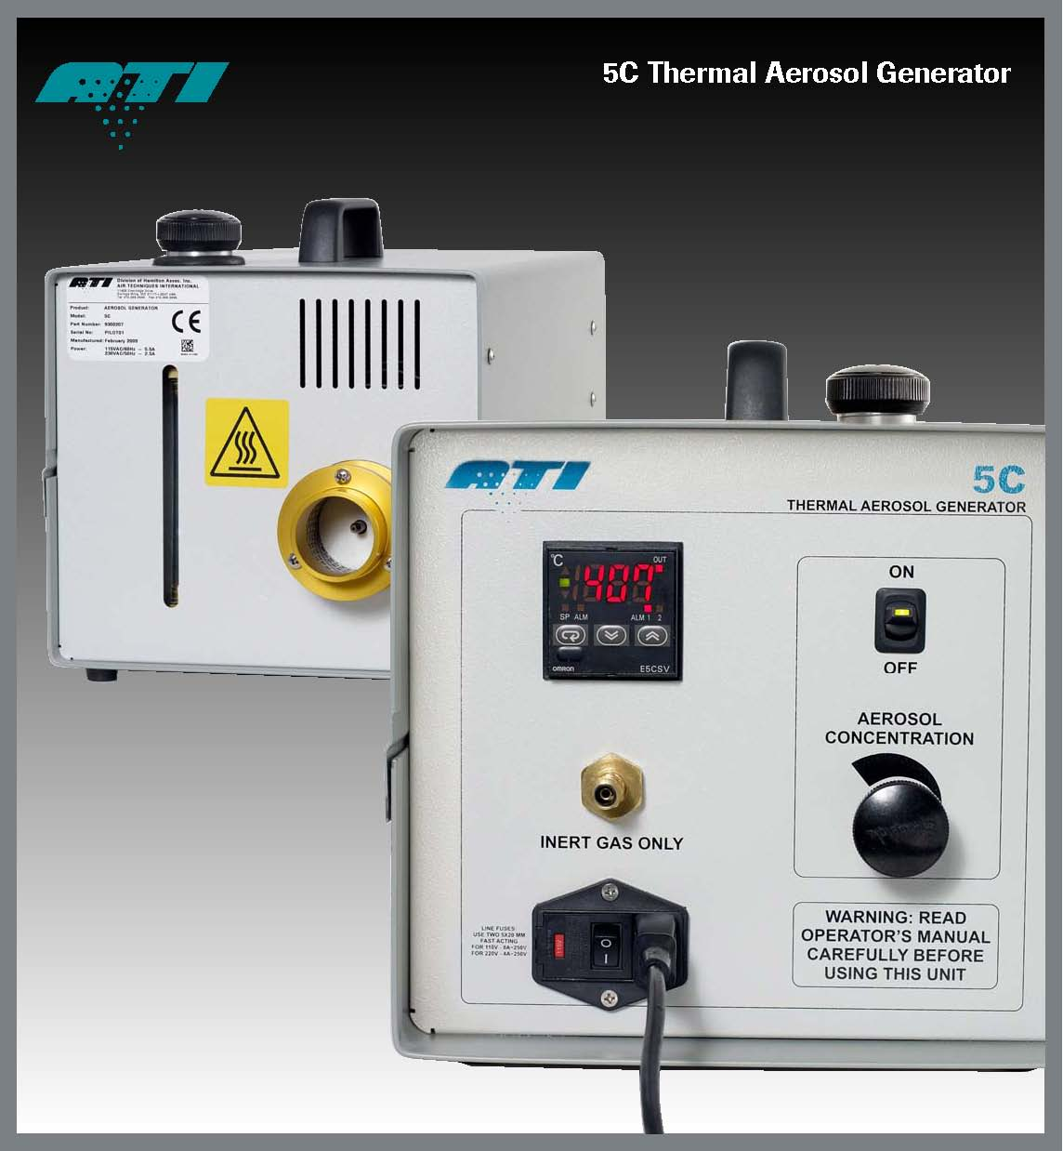

**ATI-5C热发生气溶胶发生器特点说明**

TDA-5C是一个热发生的多用途便携式的气溶胶发生器。对于认证气溶胶浓度或体积变动范围要求很宽的场合，如大的洁净室，该款产品是一个理想的选择。

TDA-5C为一些苛刻的行业应用提供了一个高容量的解决方案，比如独立的过滤器测试，军工或商业应用上的核设施，医药制造，医疗设备应用及其它应用.要验证洁净房、测试高效过滤系统或个别过滤装置时，TDA-5C是您的最好选择。

与气溶胶光度计结合使用时，用户可以检测高效过滤系统的泄漏。该款气溶胶发生器可在6500-65000立方英尺/分钟的流量范围内产生浓度范围在10μg/l-100μg/l的气溶胶。

**A tough, portable solution**

The 5C thermal aerosol generator is versatile, portable, and ideal for certification of large applications and those requiring a wide range of aerosol concentrations such as in large cleanroom plenums, particularly where compressed air is not available. The 5C provides a high capacity solution for demanding industries such as those of independent filter certifiers, military or

commercial nuclear facilities, pharmaceutical manufacturers, medical facilities, facilities with multiple cleanroom plenums, and other industrial applications.

Used in conjunction with an aerosol photometer, the user can detect and measure leakage in high efficiency filtration systems. The 5C thermal aerosol generator produces aerosol at concentrations ranging from 100 μg/l down to 10 μg/l at airflows ranging from 6,500 to 65,000 cfm.

**一个安全、便捷的设计**

该款产品引入自动防故障功能，如油路保险供应系统，加热器的热切换、倾斜自动关闭技术，以及液位观察孔等功能。这些功能使得5C成为现今最安全的热气溶胶发生器。

所有控制和显示功能均在前侧面板上，容易操作，并且远离热气溶胶喷嘴出口。这是一个大容量的气溶胶发生器，能连续操作4小时不需要重新填料。

它的数字式的温度控制允许操作员去设定在最适宜的环境下为指定的悬浮粒子所需的温度。

新型喷嘴出口设计保证在不当操作时抑制蒸汽的发生以减弱潜在安全隐患。

**A safe, convenient design**

Incorporating fail-safe features such as oil feed and thermal shut off, auto-purging of the heater block, tipping cut out technology, and a liquid level sight gauge make the 5C the safest thermal aerosol generator available today.

All controls and displays are grouped on the front panel for easy operation away from the potentially hot aerosol generator output nozzle. High liquid capacity allows for up to four hours of continuous operation without refilling.

Digital temperature control with redundant feedback allows the operator to optimize the unit for the aerosol agent being used, and aerosol output can be adjusted to accommodate specific application requirements.

A new output nozzle collar design guarantees adequate vapor quenching mitigating potentially improper operation

**易于维修**

日常预防性维护仅限于检查和确认系统的操作电压，电气连接，温度控制器和内部调节器。

**Easy maintenance**

Routine preventative maintenance is limited to inspection and validation of system operating voltages, electrical connections, temperature controller and internal regulator

**TDA-5C气溶胶发生器参数:**

**TDA-5C Thermal Aerosol Generator Specification**

**尺寸：**35cmX25cmX25cm(长X宽X高)；

**SIZE:** 14" L x 10" W x 10" H (35cm L x 25cm W x 25cm H)

**重量：**9.1KG；

**WEIGHT:** 23lbs (9.1kg)

**系统风量要求：**1500-65,000立方英尺每分钟(2547-110370立方米每小时)；

**AEROSOL OUTPUT:** 1,500 – 65,000 cfm

**悬浮粒子浓度**：流量为65,000立方英尺每分钟时浓度为10微克/升，流量为6,500立方英尺每分钟时浓度为100微克/升；

**CONCENTRATION:** 100 ug/l@ 6,500 cfm10 ug/l@ 65,000 cfm

**产生类型：**蒸气冷凝；

**GENERATOR TYPE**: Vapor Condensation

**压缩气体：**氮，氩，二氧化碳，氦 (20立方英尺/小时在50psi压力下）；

**COMPRESSED GAS:** Nitrogen, Argon, Carbon Dioxide, or Helium (20CFH @ 50psi)

**气体类型：**多分散相

**AEROSOL TYPE:** Poly-dispersed (Cold)